Software Engineering Group Project

Interaction and high level design for the system

|  |  |
| --- | --- |
| Author: | Group 03 |
| Config Ref: | SE_03_DS |
| Date: | 2015-10-17 |
| Version: | 1.0 |
| Status: | Release |

Department of Computer Science

Aberystwyth University

Aberystwyth

Ceredigion

SY23 3DB

Copyright © Aberystwyth University 2015

Contents

1. Deployment description 3

1.1 Applications in the system 3

1.2 Application Interactions 4

2. Interaction design 5

2.1 Use-Case 5

2.2 User interface design 7

3. component description 8

4. Significant classes 8

4.1 Interface description 8

5. detailed design 8

5.1 Sequence diagrams 8

5.2 State diagrams 8

5.3 Activity diagrams 8

5.4 Significant data structures 8

REFERENCES 9

DOCUMENT HISTORY 10

# Deployment description

## Applications in the system

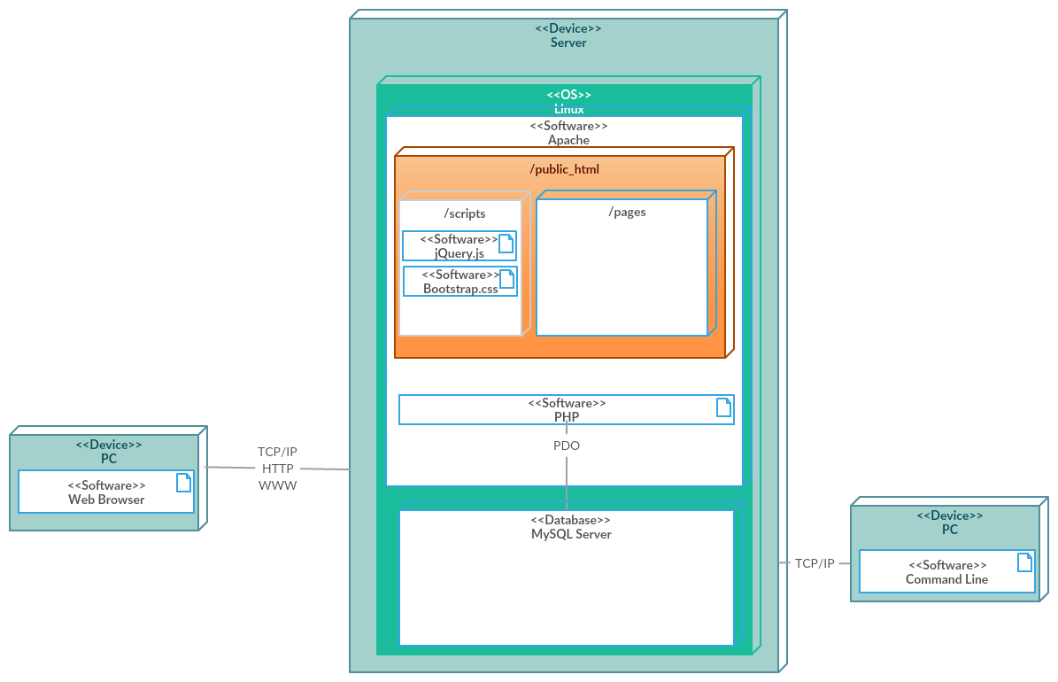

* Web Browser - user’s computer that needs a browser installed and a connection to the internet.
* TCP/IP, HTTP, WWW - data communication protocols that are going to be used to connect to the web server for access to the website (TaskerMAN) and to the database (TaskerSRV).
* Server - details of the server which runs on Linux (aber.ac.uk) that has Apache installed (Web Server) with the PHP extension installed to process PHP files. PHP extension makes calls to the MySQL DataBase(TaskerSRV) via PHP PDO Prepared statements.
* Public_html - place where we put all the files for the website, including scripts and web pages, which can be viewed via browsers. It can edit the records of TaskerSRV through a web interface using PHP, jQuery and Bootstrap.
* PC - has an Internet connection and TaskerCLI installed on to access TaskerSRV. Java program will use an email for an authorisation to communicate with TaskerSRV using JDBC and MySQL driver.

## Application Interactions

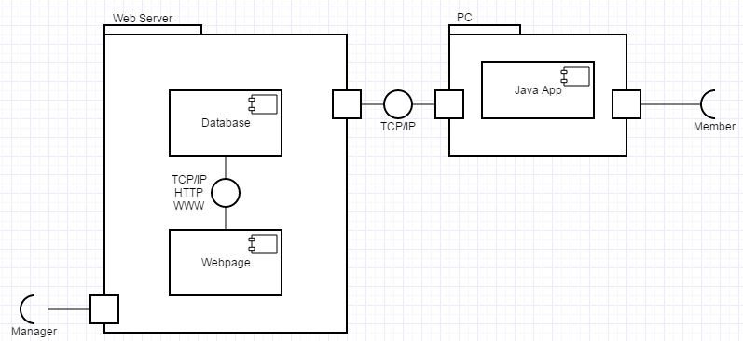

**TaskerMan**

We are using http (Hyper Text Transfer Protocol) for the website. User sends a request to a server asking for a resource (URL (Uniform resource locator)). Resource is a web page (.html or .php or some other file mp3 or image).

User sends a request by typing the URL into the address bar, e.g. www.bbc.co.uk or www.google.com. Once they press enter, browser generates a HTTP request and sends it to the URL.

Once the server receives that request, it then responds with the (html/php/mp3) file you asked for, by delivering it to your browser. Chrome/Firefox rendering engine looks at the codes and displays all the links/pictures/text in the way it was intended.

**TaskerCLI**

Java program works by transmitting data packets (TCP Packets) from the user using the program to the MySQL database (TaskerSrv).

# Interaction design

## Use-Case

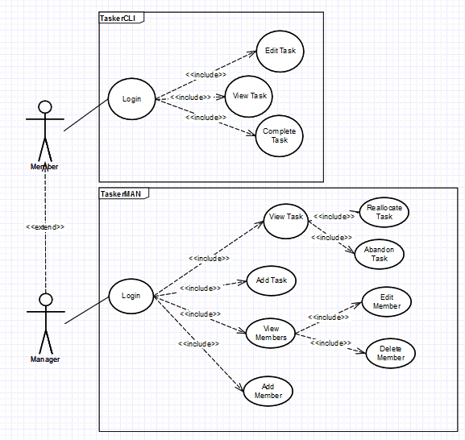

**Member**

* Member only allow to login TaskerCLI, the desktop application.
* Member allow to view task, a list of assigned works with description.
* Member able to edit task to change the current task details.
* Member able to mark current task as a complete, complete task.

**Manager**

* Manager extends the member and allow to login TaskerMAN, website.
* Manager can view the current task.
* Manager has to view task to reallocate task or abandon task.
* Manager allow to add new task.
* Manager can view group members.
* Manager has to view members to edit members or delete members.
* Manager allow to add new member.

**Example Usage Scenarios**

Complete task

* Member login into TaskerCLI and mark the completed task as complete.

View task

* Member login into TaskerCLI and click on "View Task" button, a list of task will be display.

Abandon task

* Manager has to login into TaskerMAN, then click on the "View Task" button to select which task to abandon.

Add member

* In order to add new member, Manager login into TaskerMAN follow by clicking the "Add New Member" button.

## User interface design

**TaskerMAN**

**Opening screen:**

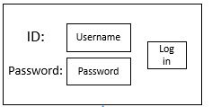

On opening, the system will ask the user to specify their username and password.

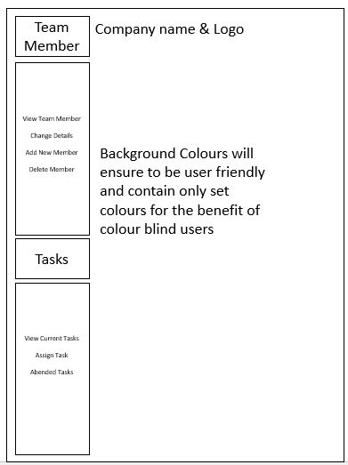

Manipulation of team member data. All of the options below opens new window, which is described later.

* Change details
* Add new members
* Delete members
* View member

Addition and allocation of task data. All of the options below opens new window, which is described later.

* View current tasks
* Assign tasks
* Input task date
* Start date
* Completion date
* Any other notes

Relocation of task. All of the options below opens new window, which is described later.

* Allow users to choose other tasks and move to certain members
* Abandonment of tasks
* Allow users to abended task

**View user/Change Member Details:**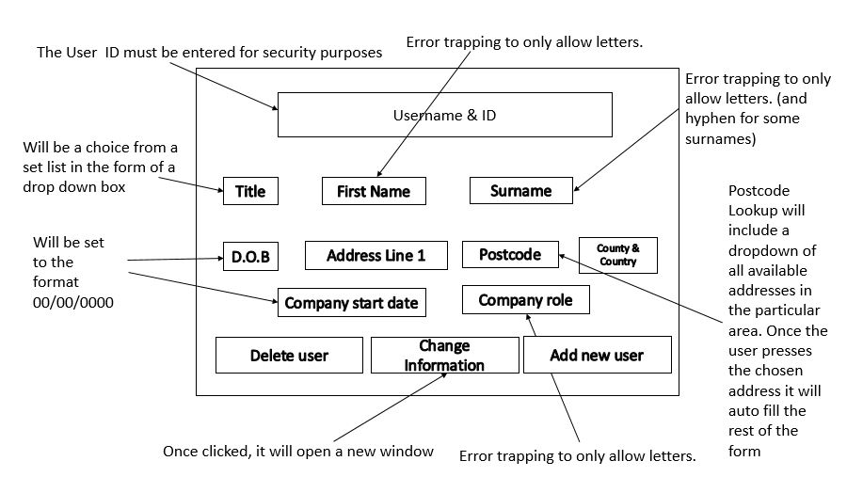

If we want to change details, we need to give a brief description why we want to change details:

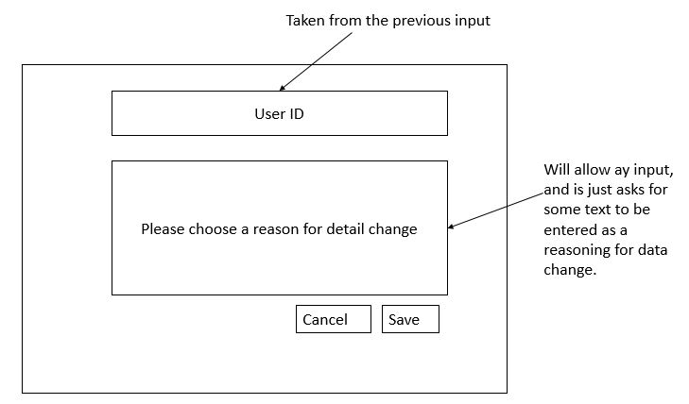

All fields in the main window will be blank, and once all fields are filled in, the message box ‘record added’ will appear:

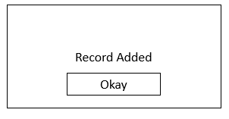

User will be asked if they want the current record, shown on the screen to be deleted. If yes, the record will be deleted and leave the filed blank, if not, the warning box will disappear and will go back to the previous page.

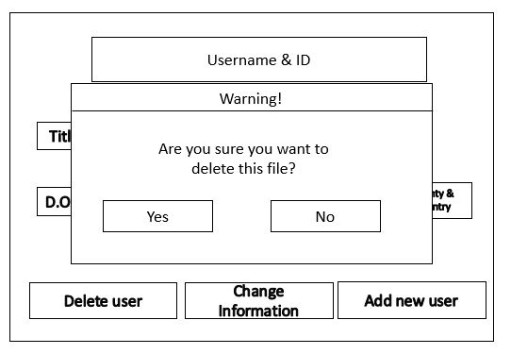

­­­­

**View/Edit Tasks:­**

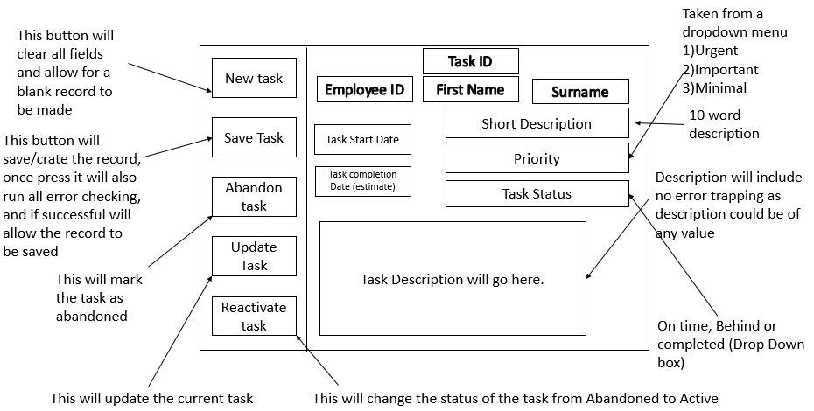

**TaskerCLI**

**Opening screen:**



On opening, the system will ask the user to specify their username and password.

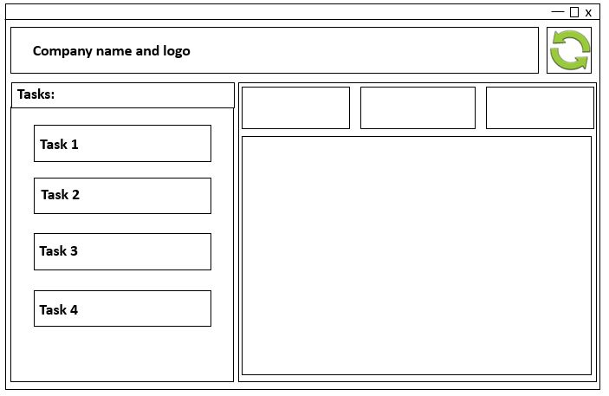

List of tasks on the left will be sorted by update date and priority.

Big green synchronisation button will update our local storage with the database.

**View task details**

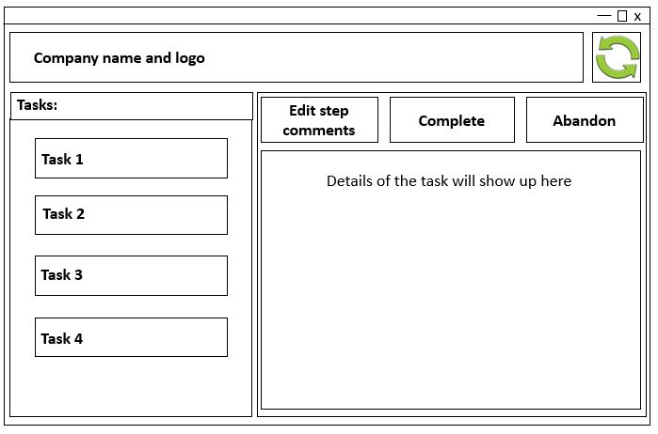

By clicking at one of the tasks we will open up right side of the screen.

Details of the task will consist of:

* Priority of the task
* Task start date
* Task due date
* Short description
* Task status (On time, behind or completed)

We are able to click on 3 buttons above the details which are:

* Edit step comments
* Complete task – marks task as complete and finishes it by adding completion date to the database and website.
* Abandon task - deletes the task, marking is as incomplete/abandoned. Warning window will pop up as showed below.

**Warning pop up window:**

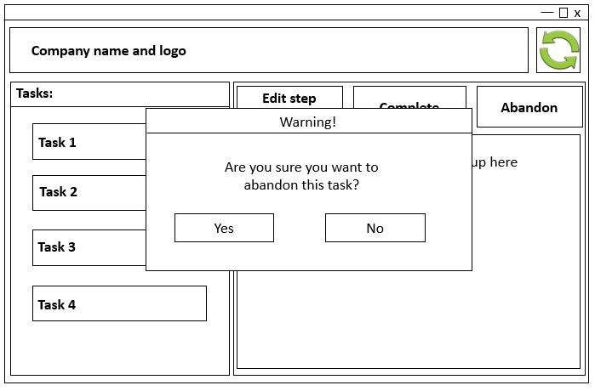

User will be asked if they want the current task to be abandoned. If yes, the task will be marked as abandoned and leave the field blank, if not, the warning box will disappear and will go back to the previous page.­­­

# component description

# Significant classes

## Interface description

# detailed design

## Sequence diagrams

## State diagrams

## Activity diagrams

## Significant data structures

REFERENCES

DOCUMENT HISTORY

| *Version* | *CCF No.* | *Date* | *Changes made to document* | *Changed by* |
| --- | --- | --- | --- | --- |
| 1.0 | N/A | 27/10/2015 | N/A - original version | Group03 |